# Technical Documentation

**MediCare**

**By Atary : 22034818**

1. **System and User Requirements**

List all system and user requirements (10 requirements).

**User Requirements:**

1- The possibility of registering patients for an account with unique identifiers (email, password) to access the system.

2- A secure login process that ensures confidentiality and data security.

3- The ability to update and manage personal information (name, contact details, address, nationality, date of birth) of patients.

4- View the information of the booked facility and the associated dates.

5. View the appointment date and upcoming schedules.

6- The ability to reserve a facility for specific medical purposes.

7- Prevent multiple facilities from being booked by the same patient at the same time.

8. Access to information about available medical equipment.

9- The ability of patients to use and reserve specific equipment.

10. Ensure that personal data is secure and cannot be accessed by unauthorized individuals.

11- Confirm data backups for reliability.

**System Requirements:**

1. Secure login system with encrypted password storage.

2. Authorization protocols for access control based on user roles (patient, doctor, staff).

3- A central database to store patient information, doctor details, nurse and staff details, facility information and equipment data.

4. Unique identifiers (IDs) for patients, doctors, facilities and equipment for efficient data retrieval.

5. Validations to ensure data integrity (e.g., unique email constraint, mandatory fields).

6. A system to handle facility bookings by patients and allocate equipment for patient use.

7. Regular and automated data backup to prevent data loss in case of system failure or data corruption.

8- Implement data encryption methods to protect sensitive patient information.

9. Monitor and record the activities of the system for the purposes of security analysis and auditing.

10- System logic to ensure that the default values (Jordanian) are set when the necessary data is not provided.

11. Flexible network infrastructure to ensure smooth connectivity, especially during high load times.

1. **Entity Relationship Diagram**

Insert your Entity Relationship Diagram (ERD) that you have built based on the vocational scenario.

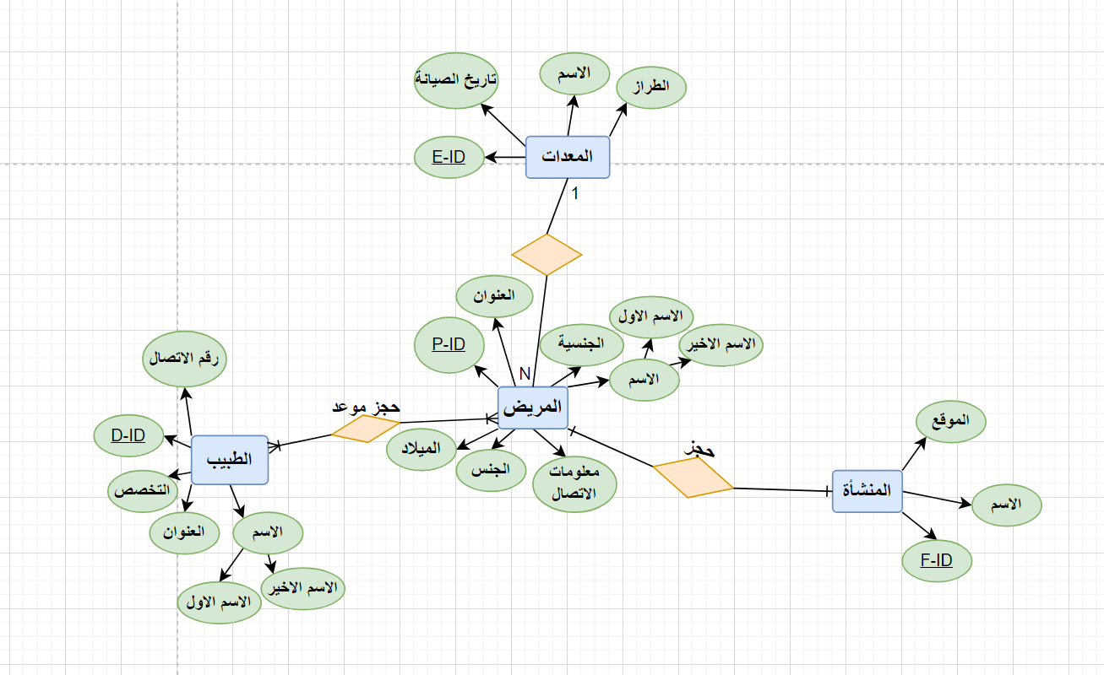

1. **Database Tables**

Insert the database tables (SQL) that you have created based on the vocational scenario. Provide the images as well not only the syntax.

**Doctor, Patient:**

**Appointment:**

**Equipment:**

**Facility:  
**

1. **Hosted Cloud Database system**

Insert the method of how you hosted your database. Provide the images as well.

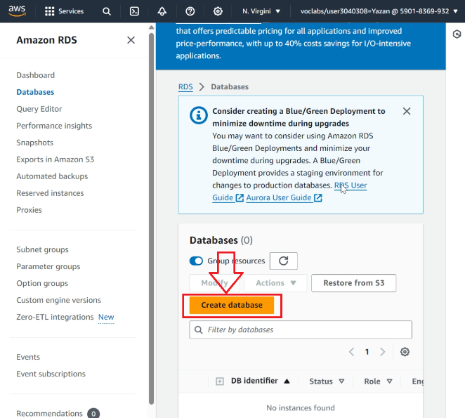

1. **Cloud Database Performance and Measurements**

Present the performance and measurements for your cloud database system.

1. **Cloud Database Backup**

List the method and images of how you backup your cloud database system.

1. **Queries**

List all the queries you have applied on your database system. Provide the images as well not only the queries (operations).

**Appointment:**

**Equipment:**

**Facility:  
**

**SELECT.**

**Retrieve all columns for all patients**

**Group by.**

**Statistics of the number of patients per city**

**Between**

**Retrieve patients with an ID between 1 and 3**

**Where.**

**Recovery of patients of a specific sex**

**Order by.**

**Retrieve patients sorted by date of birth in descending order**

**Join.**

Retrieve patient details along with associated equipment information

1. **Interface Design**

List all the interface sketches (input and output) you have created based on your database system.

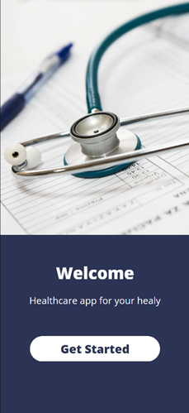

**VS INTERFACE:**

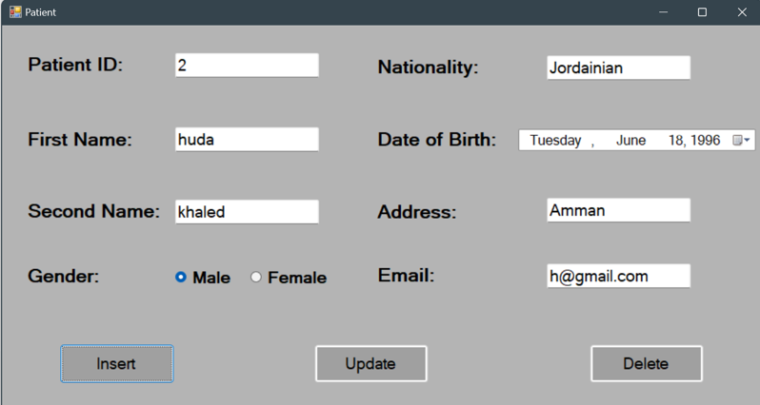

1. **Flowchart Diagram**

**How the application works**

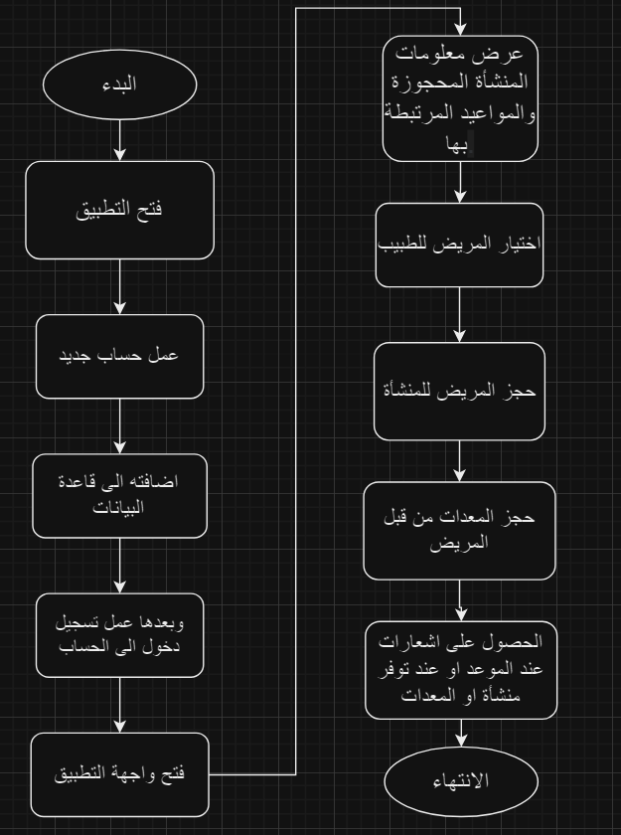

**Steps to work the application**



